*Name: Wellens Rufus Course: CSC 235*

*Martic number: 222517*

**UNIX OS and C language**

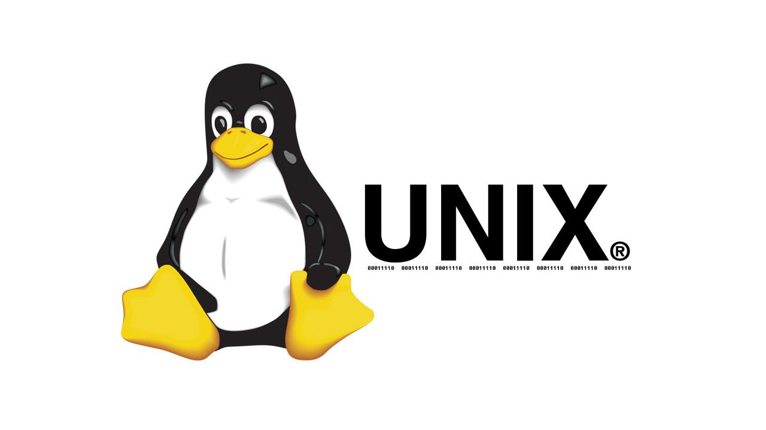

**What is an Operating system?**

An operating system is a set of programs which acts as an interface between users and computer hardware. It can also be called software that controls the operation of a computer and directs the processing of the programs.

**UNIX**

Unix is a **proprietary(closed-source)Operating** system which can handle multiple users at the same time. It is basically a set of programs that acts as a link between the computer and the user.

Unix was written in the C programming **language.**

It was originally developed by Ken Thompson and Dennis m.Ritchie. The name Unix originated from the name of the parent Os called **MULTICS.** Some Unix Os are open source while some are not. The shell is a **command line interpreter**.

**Features Of UNIX**

* Unix is a multi-tasking, multi-user OS
* Unix file system is a hierarchical model
* Unix is a CUI(command user interface) OS
* Unix is a free-source OS
* It is case sensitive

**LINUX**

Linux(Redhat) which is a Unix flavor, is an Open source, a free-to-use operating system widely used for computer hardware and software game development, tablet pcs, etc. It can also be defined as a Unix-like, open source and community-developed operating system for computers, servers, mainframes, and mobile devices.

**Features Of LINUX**

* It is a portable environment
* It is a free and open source
* It comes with a GUI same way as windows
* Linux can configure the keyboard to different languages



**LINUX Flavors**

Linux flavors are the different versions of Linux that we have. Linux flavors are divided into three categories with their own particular use.

1. **Security-focused:** Distros from the Security-Focused category are best used in situations where there is an elevated need for security-related features. Examples include **Qubes OS, Kai Linux, and Parrot Security OS.**

## **User-focused:** As the name suggests, this section will detail more user-friendly distros. These Linux distros require a lower level of Linux skill and tend to be implemented more for ease and simplicity than for their security features. Examples include **Ubuntu, Elementary Os, and Linux mint.**

## **Unique:** Unique Linux distros are those that have a particular specific use which is either specially focused or novelty. Examples include **Suicide Linux and Hannah Montana.**

**Software Functional Requirement**

**What are Functional requirements?**

A Functional Requirement (FR) is a description of the service that the software must offer. it describes a software system or its components. A function is nothing but inputs to the software system, its behaviour, and outputs. It can be a calculation, data manipulation, business process, user interaction, or any other specific functionality which defines what function a system is likely to perform.

**Functional Requirements in Software Engineering** are also called **Functional Specification**. In software engineering and systems engineering, a Functional Requirement can range from the high-level abstract statement of the sender’s necessity to detailed mathematical functional requirement specifications. Functional Software requirements help you to capture the intended behaviour of the system.

**Why is UNIX Often Preferred at Some Point?**

Unix is often preferred to other OS at some point because.

* **Less usage of memory:** Unix Operating system handles virtual memory more efficiently. Fewer resources are utilised for its job.
* **Supports multitasking, multi-processing and multi-user:** Several users can access the Unix OS.
* **Free:** It's free and it's also customizable.
* **Secure:** Unix gives a secure and safe platform for multiple users. Each user requires to be authenticated to access the operating system.

**Why does UNIX being referred to as a Scientist OS?**

Unix is referred to as a scientific operating system because almost all supercomputers in the world used for scientific research is has a variant of Unix as their operating system, also many early adopters of the Unix operating system were schools and scientists. It's also popular because it's better at handling large amounts of data than other operating systems.

**What kind of language is C?**

**C** is a general-purpose programming language that is extremely popular, simple, and flexible to use. It is a structured programming language that is machine-independent and extensively used to write various applications, Operating Systems like Windows, and many other complex programs like Oracle database, Git, Python interpreter, and more.

It is said that ‘C’ is a god’s programming language. One can say, C is a base for programming. If you know ‘C,’ you can easily grasp the knowledge of the other programming languages that use the concept of ‘C’

It is essential to have a background in computer memory mechanisms because it is an important aspect when dealing with the C programming language.

C is a **compiled language**. A compiler is a special tool that compiles the program and converts it into a machine-readable object file. After the compilation process, the linker will combine different object files and creates a single executable file to run the program

**Structure Of C programming**

The structure of the C programming language can be mainly divided into six parts, each having its own purpose.

1. **Documentary** - Consists of the description of the program, programmer's name, and creation date. These are generally written in the form of comments.
2. **Link -** Consists of the description of the program, programmer's name, and creation date. These are generally written in the form of comments.
3. **Definition** - Includes preprocessor directive, which contains symbolic constants. E.g.: #define allows us to use constants in our code. It replaces all the constants with its value in the code.
4. **Global Declaration** - Includes declaration of global variables, function declarations, static global variables, and functions.
5. **Main()function** - For every C program, the execution starts from the main() function. It is mandatory to include a main() function in every C program.
6. **Subprograms** - Includes all user-defined functions (functions the user provides). They can contain the inbuilt functions and the function definitions declared in the Global Declaration section. These are called the main() function.

**Steps to creating a C programming file on OS**

* Click on the start button
* Open system terminal
* Type in the **vim filename.c**
* Exit the vim space
* Compile the program to get the executable
* Run the executable